**MODULE 39: THEORY FINAL EXAM**

1 Traverse the following binary tree using the inorder, preorder, postorder, and level order techniques. Level each of the nodes of the tree. Also, find the height of the tree. (8)

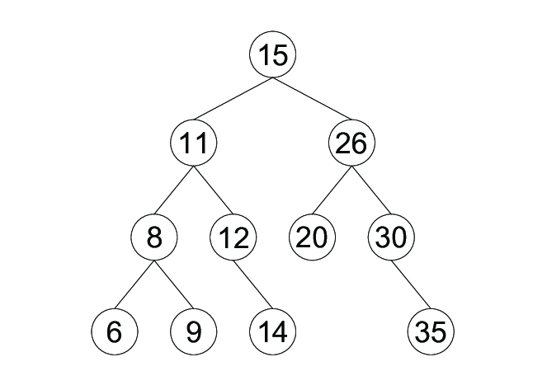

2 Draw a binary tree using the given preorder and inorder sequences (5)

Preorder: ABDEFCG

Inorder: DBFEACG

3 Draw a binary tree using the given inorder and postorder sequences (5)

Inorder: DBEFAGC

Postorder: DFEBGCA

4 Draw a max-heap and min-heap trees from the following data where X=last digits of your birth month + 1 . 10 40 20 8 99 X 15 17 (5)

5 Use HeapSort to Sort the Data in Descending Order. Show the status of the array and heap in each iteration. Data: 20 50 40 5 30 15 (7)

6 Draw a binary search tree for the following data 10 40 20 8 99 16 15 17 11 14 1. Can We insert duplicate values in BST? State your opinion with a logical explanation. (6+2)

7 Perform the Following Operations on the BST given in the Figure below. (2+2+2)

* Delete 12
* Insert 11
* Delete 6

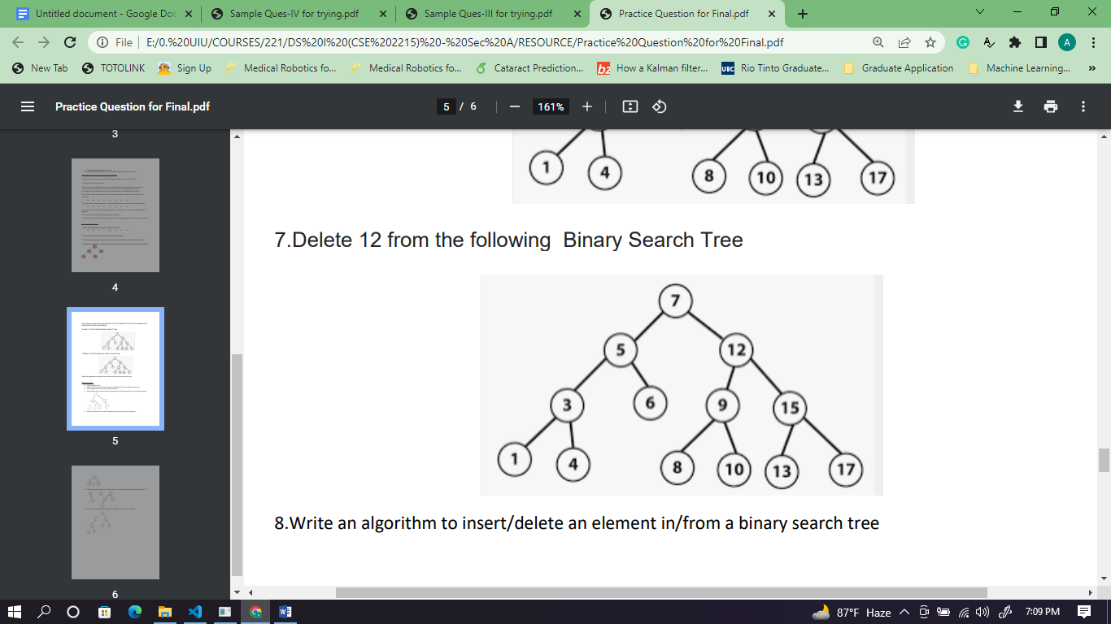

8 Given Infix Notation: (5*((6^2)+(7-(2/6))))-((7*(8+1))+(5*4)) (4+2+4+2)

1. Convert it into Prefix Notation using Stack and Show the status of Stack and Console in all the steps
2. Evaluate the Prefix Notation derived in (A) using Stack and Find the result of the statement. Show the status of the Stack in each step.
3. Convert it into Postfix Notation using Stack and Show the status of Stack and Console in all the steps
4. Evaluate the Postfix Notation derived in (C) using Stack and Find the result of the statement. Show the status of the Stack in each step.

9 Write down all the steps of Counting Sort on the Following Array. (4)

| Index | 0 | 1 | 2 | 3 | 4 | 5 | 6 | 7 |
| --- | --- | --- | --- | --- | --- | --- | --- | --- |
| Value | 3 | 3 | 1 | 7 | 7 | 4 | 4 | 5 |

10 Comparing the time and space complexity, give your opinion on the following statement (2)

***HeapSort is more efficient than Counting Sort***

11 Find the location of A[15] [20] for the following data int A[50][100]. Assume, loc(A[0][0])= (AE92F6)H and Assume column-wise memory allocation (An Integer is a word addressable (4 bytes) datatype) (5)

12 Answer the following questions for the doubly linked list as shown below, where p = 12 , q = p+4, r = p+q, s = r-3, t = r+s. (5)

a) head −> next −>next-> value = ?

b) last −> prev −> next->value = ?

c) temp −> prev −> prev −> prev= ?

d) temp −> next−> prev −>prev->value = ?

e) last −> prev −> prev −>next-> value = ?

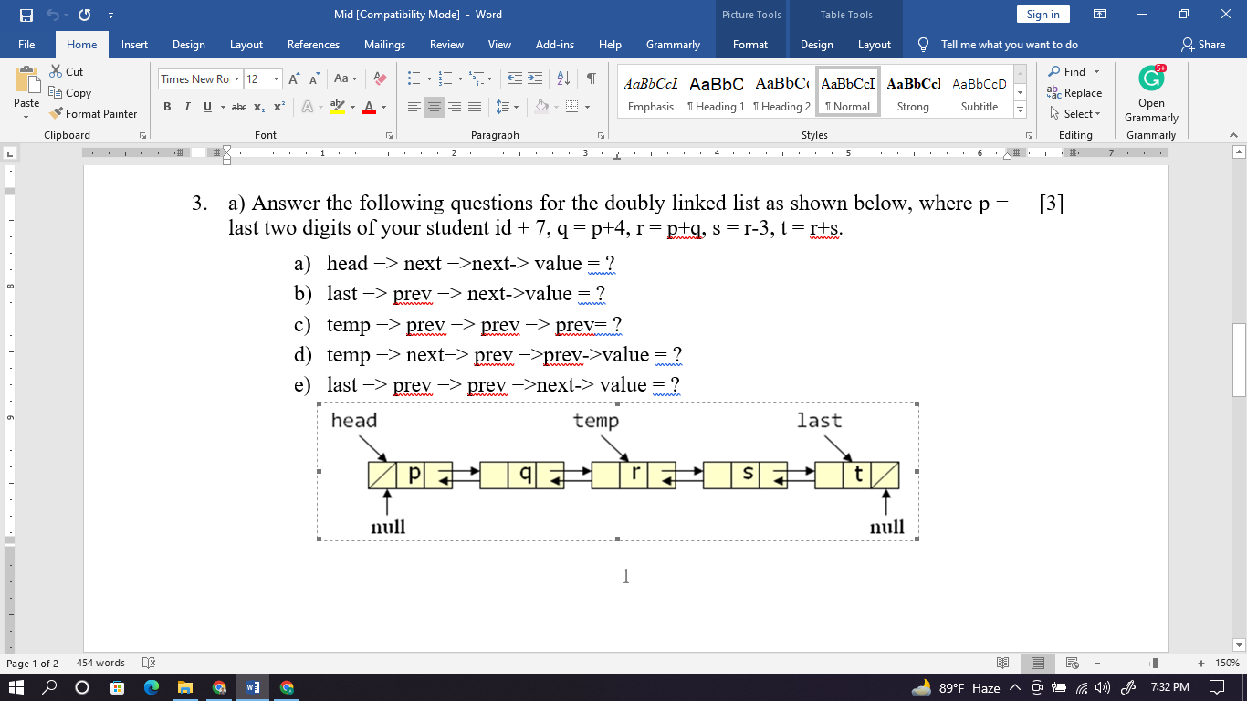

13 Write an algorithm to display the data stored in a doubly linked list in reverse order. Assume only the head pointer is given for the linked list. What are the merits and demerits of a doubly linked list over a linear linked list? (4)

14 Show the status of a QUEUE and PRIORITY QUEUE for the following operations, where the QUEUE is implemented by an array of sizes, m=3. Here, Enqueue and Dequeue mean insert and delete respectively, and x=9, y=x+3, z=x+y, and p=y+z. (3+3)

Enqueue(z), Enqueue(p), Dequeue(), Enqueue(y), Enqueue(z)

15 What are the merits of implementing a QUEUE using Array in a circular fashion? How do you check the underflow and overflow in the QUEUE implemented circularly? (2+2)

16 Given the root of a binary tree, Write down a function to invert the tree and return its root.Node* invert_tree(Node* root) (6)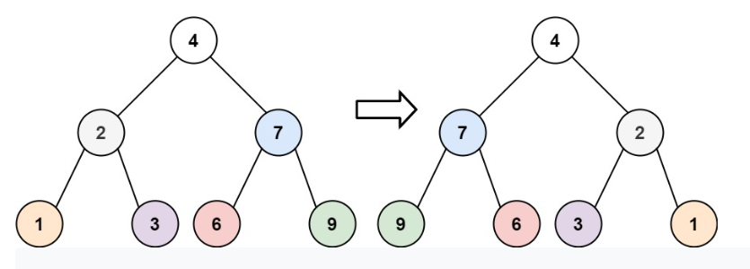

17 Write down the Pseudocode of the following traversals in the Binary Tree. (4+4)

1. Boundary Traversal: 15 11 8 6 9 14 20 35 30 26
2. ZigZag Level Wise Traversal: 15 26 11 8 12 20 30 35 14 9 6

